**"'Examining the Impact of Social Media and Online Gaming, on Student Achievement’. A Data Driven Study"**

Ian Mantilla, Arnel P. Tagupa

1. **Introduction**

The study titled 'Examining the Impact of Social Media and Online Gaming, on Student Achievement' seems to explore how the utilization of media and online gaming influences students’ academic performance. This research falls within the realm of psychology aiming to shed light on how digital technologies shape students learning [1]. I’ve actually seen this happen to a student. They struggle to focus on their studies because they're always checking their phones for notifications. It’s gotten to the point where some of them are neglecting activities and losing touch with their connections. I remember James she used to be a student and we were classmates. This year his academic performance has taken a hit. He constantly glued to his phone scrolling through media or playing games. It’s gotten bad that she even nods off during class. That why Data Analytics is one of the best way to understand the social media and online gaming to know a student performance. This knowledge can assist us in developing strategies to assist students in improving their learning experience and personal growth [2].

Previous research on the impact of social media and online gaming on academic attainment resulted in opposite outcomes. Excessive use of social media and online gaming, according to some authors, can lead to distractions and poor academic performance for example, conducted a study that discovered a negative relationship between the amount of time students spent on social media and their total GPA [3]., on the other side, argued that when used in moderation and with proper time management, online gaming can have positive effects on students' cognitive skills and problem-solving ability [4]. These differences highlight the need for a more complete and data-driven examination to better comprehend the true impact of these digital technologies on student achievement.

While the present literature gives useful insights into potential effects of social media and online gaming on students, important gaps remain unresolved. The lack of detailed quantitative data analysis to investigate the relationship between certain social media platforms, types of online games, and their impact on student achievement is one noticeable gap [5]. Furthermore, many past research relied on self-reported data, which might be biased and inaccurate. To close these gaps, our research applies data analytics and a more objective way to determine the precise impact of different digital technologies on academic performance [6]. We look to close these gaps in knowledge and provide a deeper comprehension of the subject.

Finally, our research, titled 'Exploring the Influence of Social Media and Online Gaming on Student Academic Performance,' is driven by a compelling need to understand the impact of these digital technologies on students' educational achievements [7]. We endeavor to offer data-driven perspectives on this issue, drawing from firsthand observations of students struggling academically due to excessive screen time [8]. By examining specific data, we try to bring insight into the complex connection between social media, online gaming, and student success [9]. This critical information will be used to build strategies for improving students' learning experiences and personal development, which will help both the individual and the educational system as a whole.

1. **Review of Related Literature**

A. Overview of the Study

We've been exploring how certain algorithms can help us understand and predict students' academic performance. In a paper called " Implementation of the K-Nearest Neighbor (kNN) Method to Determine Outstanding Student Classes" by Munazhif Nanda ,Yanris Gomal , Hasibuan Mila (2023), they delve into the use of the KNN algorithm to predict Outstanding Student Classes The study shows that KNN is really good at handling large amounts of data and making accurate predictions [10].

Another approach we've looked at is using Support Vector Machines (SVM) in educational research conducted a study titled " Enhancing Predictive Accuracy: Assessing the Effectiveness of SVM in Predicting Medical Student Performance " where they talk about how SVM can identify and predict student performance based on various factors. The research demonstrates that SVM is robust in dealing with complex interactions in educational datasets [11].

Nave Bayes, as explored by Khalaf, Alaa, Humadi Aqeel, Akeel Wid, Hashim Ali in their study " Students’ Success Prediction based on Bayes Algorithms is another method for predicting student achievement. They highlight the simplicity and efficiency of Nave Bayes in handling diverse data inputs for reliable predictions [12].

There's a growing emphasis on using data-driven approaches to assess student achievement, Maramag and Palaoag (2019) stress the importance of using advanced analytics to find patterns and trends affecting academic success. Their article, " Assessing CSU Students' Academic Performance on iLearn Portal Using Data Analytics," suggests using data analytics tools in education to enhance understanding and decision-making [13] .

Researchers like Novak, McDaniel and Li (2023) have conducted comprehensive evaluations of how digital technology impacts academics. Their study, " Factors that impact student frustration in digital learning environments," covers various technologies like social networking. The research underscores the need for in-depth analysis to capture the diverse influences of different learning environment [7].

A. Existing Literatures / Existing study

Beñalet and others (2023) looked into how social media usage affects students' Academic Performance, " The Influence of Social Media Usage and the Level of Motivation on Students' Academic Performance: A Linear Regression Analysis." They found potential harmful consequences of excessive social media use on academic performance, suggesting the need for more research in this area [14].

There are different opinions on the impact of online gaming on academic achievement. Tshering and Lama Yolmo, (2021) present a Positive and Negative Affect view in their study, " Effect of Online Gaming on Positive and Negative Affect and Psychological Wellbeing," indicates that addiction to gaming has more negative consequences than positive [15]..

To address gaps in previous research, Ibañez and Velza (2023) conducted a study titled " Impact of Online Gaming on the Academic Performance of DEBESMSCAT-Cawayan Campus Students." They investigated the effects of online gaming on the academic performance of students of DEBESMSCAT-Cawayan Campus. The study advocates for a more thorough and impartial method of evaluating the influence of digital technology on student accomplishment [16].

In summary, these studies give us a comprehensive view of algorithmic and data-driven approaches, like KNN, SVM, and Nave Bayes, for evaluating student academic achievement. Additionally, existing literature provides a range of perspectives on the impact of social media and online gaming, underscoring the need for a sophisticated and data-driven investigation to understand the complex connections between digital technologies and student success.

1. **Methods**

1. *Framework of the study*

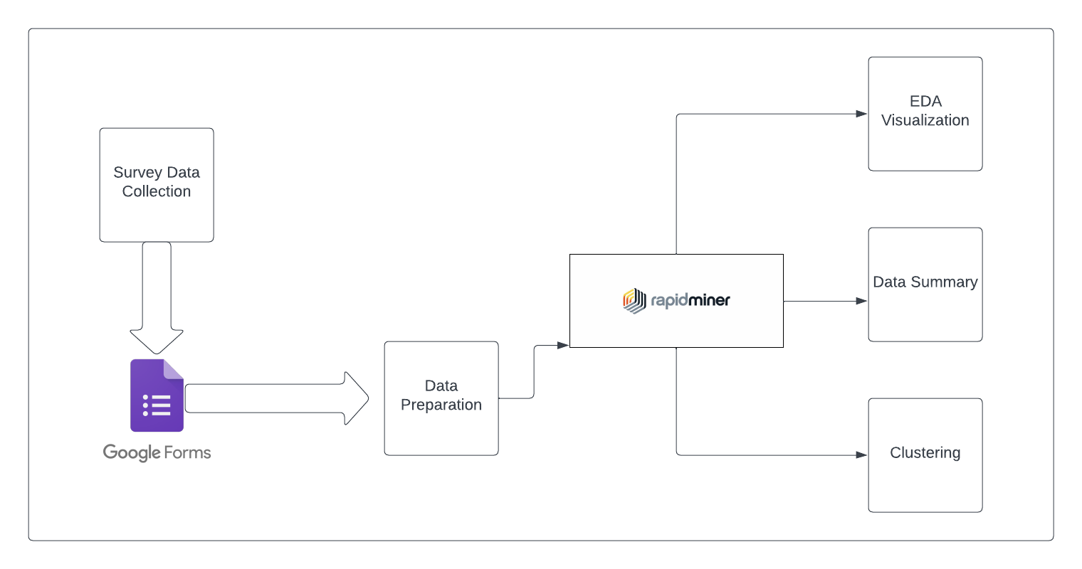

*Figure 1. Framework of the Study*

*A. Survey and Data Collection*

*1. Conducted a survey with Caraga State University using Google Form in social media and online games*

*2. Gathered data on social media users and online gamers.*

*B. Data Preparation*

*1. Used RapidMiner for data cleaning and transformation.*

*2. Ensured data integrity by addressing missing values and outliers.*

*3. Formatted variables consistently.*

1. *Dataset Description*

*Description:*

*This dataset contains the reasons for the students who use social media and online gaming, as well as what is their academic performance for using this technology and what will they about it. On the other hand, we collect information from students who spend more time in using this technology and how they maintained their grades as well as using this technology.*

*Data Source:*

*The information in this dataset was gathered through surveys conducted at Caraga State*

*University and made available online via a link in a Google form. Students are asked to respond to a series of questions, and the collected responses are included in the dataset.*

*Key Attributes:*

|  |
| --- |
| *On average, how many hours a day do you spend playing online games for non-academic purposes?* |
| *How often do you play online games during class or study time?* |
| *Does online gaming have a positive or negative impact on your academic performance?* |
| *How many hours a day, on average, do you spend on academic or study-related activities?* |
| *On a scale of 1 to 5, how would you rate your current academic performance, with 1 being very low and 5 being very high?* |
| *In your experience, do you find it challenging to balance social media and online gaming with your academic commitments?* |

|  |
| --- |
| *Name* |
| *Email* |
| *Age* |
| *Year Level* |
| *College* |

|  |
| --- |
| *Which social media platforms do you use regularly?* |
| *On average, how many hours a day do you spend on social media for non-academic purposes?* |
| *How often do you check your social media accounts during class or study time?* |
| *Does social media have a positive or negative impact on your academic performance?* |
| *Which online games do you play regularly? (Select all that apply)* |
| *Do you plan to make any changes to your social media or online gaming habits to improve your academic performance in the future?* |

1. **Results and Discussion**
2. *Results*

*A. Key Findings*

*1. Students hours in a day they spend on social media.*

*4-5 hours (35 students), 2-3 hours (27 students), 3-4 hours (33 students), 1-2 hours (3 students), and more than 5 hours (8 students) are the hours of students they spend on social media according to our survey.*

*2. Students hours in a day they spend on online-gaming.*

*4-5 hours (1 student), 2-3 hours (30 students), 3-4 hours (14 students), 1-2 hours (59 students), and less than 1 hours (3 students) are the hours of students they spend on online gaming according to our survey.*

*3. Students play online games during class or study time.*

*53 students say they Rarely, 43 students say they Never, 9 students say occasionally and 1 students say frequently play online games during class or study time.*

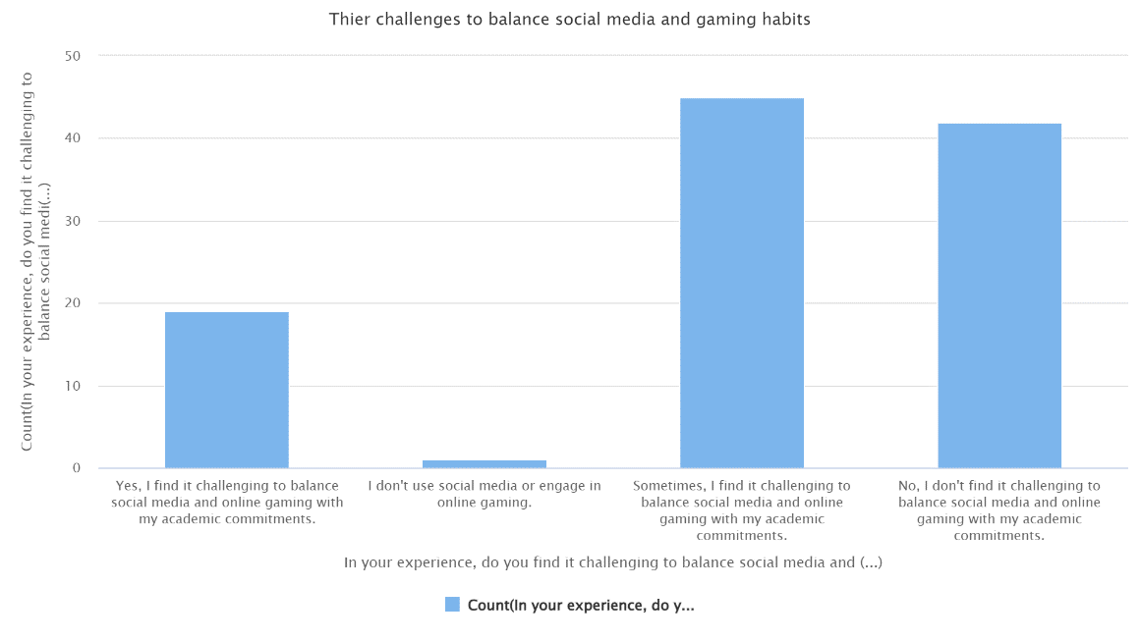

*Figure 2. Their Challenges to balance social media and gaming habits*

*Figure 2 illustrates the distribution of the challenges of the students with their social media screen time and their gaming habits among the students at Caraga State. The bar plot provides insights into the experience of every student in their social media and gaming habits. Notably, it reveals that majority of the students Sometimes find it challenging to balance their social media and online gaming habits in their academic commitments.*

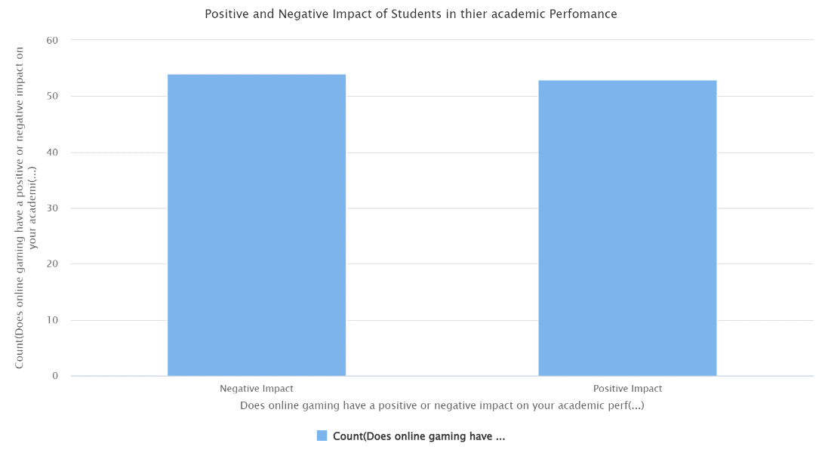

*Figure 3. Positive and Negative Impact of Students in their academic performance*

*Figure 3 illustrates the distribution of the positive and negative impact of students with their academic performance among the students at Caraga State University. The bar plot provides insights into the experience of every student in their current academic performance. Notably, it reveals that negative impact have been the majority of students in their current academic performance.*

*B. Classification Results*

*Table 1. Results of the Classifier model*

|  |  |
| --- | --- |
| *Classifier Model* | *Accuracy* |
| *K-Nearest Neighbor* | 39.60% |
| *Support Vector Machine* | 41.58% |
| *Naïve Bayes* | 43.56% |

*Table 1 shows the results of the classifier model in terms of accuracy when the grades dataset is trained and tested. In the table it can be seen that Naïve Bayes model outperforms the results of both KNN and SVM with the accuracy result of 43.56%.*

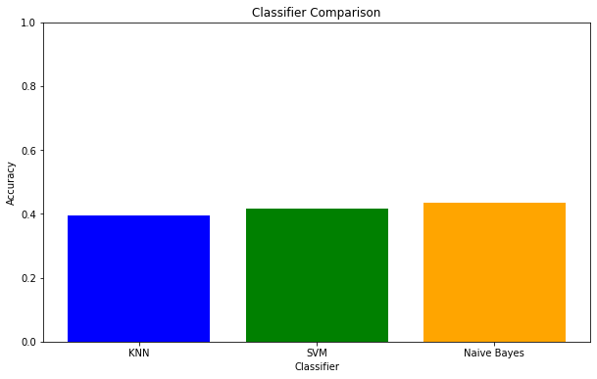

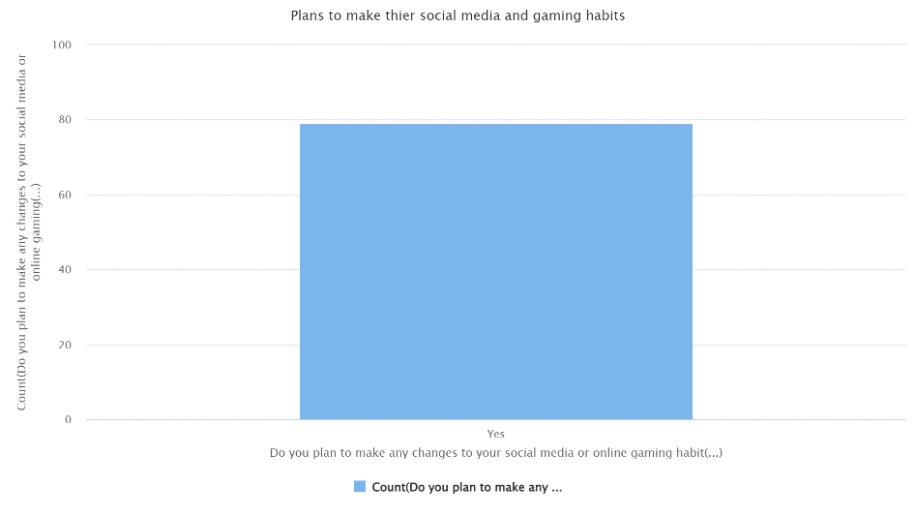

*Figure 4. Students plans to make any changes to their social media or online gaming habits to improve their academic performance in the future.*

*Figure 4 illustrates the distribution of the Students plans to make any changes to their social media or online gaming habits to improve their academic performance in the future among the students at Caraga State University. The bar plot provides insights into the experience of every student in their if they have plans to make any changes in their social media and gaming habits for their academic performance in the future. According to the figure 3, it reveals that negative impact have been the majority of students in their current academic performance. That’s why in figure 4 majority of the students says yes that they have plans to improve their academic performance in their future.*

1. **Conclusion**

Summary of Findings:

* The study revealed diverse perspectives on the impact of social media and online gaming on academic performance.
* Different opinions were observed in existing literature, emphasizing the need for a sophisticated and data-driven investigation.
* Algorithmic approaches such as K-Nearest Neighbor (KNN), Support Vector Machine (SVM), and Naïve Bayes were employed for predicting student academic achievement.

Discussion of Classifier Model Results:

* The study employed KNN, SVM, and Naïve Bayes as classifier models, with Naïve Bayes showing the highest accuracy at 43.56%.
* The accuracy results emphasize the challenges in predicting academic performance based on social media and online gaming habits.

The study titled 'Examining the impact of social media and online gaming on student achievement', the study found that social media and online gaming have both positive and negative effects on academic achievement, with most students reporting negative outcomes This personalizes students’ learning experiences. The importance of understanding these effects in order to develop strategies that also strengthen development is emphasized. The study’s data-driven approach provides a comprehensive view of the complex interplay between digital technologies and student success. The insights gathered form the basis for developing strategies to help students enhance their academic achievement while balancing technology use with academic commitments. Furthermore, the study recommends thorough and unbiased research, filling gaps in previous research and providing valuable information to inform educational decisions.

|  |  |
| --- | --- |
| **Questions** | **Attributes** |
| 1. How many hours per day, on average, do you spend on social media platforms? | Hours_per_day |
| 2. Do you often use social media while studying or doing homework? | Use_of _social media(studying or doing homework) |
| 3. Do you engage in online gaming activities? If yes, how many hours per week do you spend on online gaming? | Hours_per_week |
| 4. Have you noticed any changes in your academic performance over the past year, either improvements or declines? | Perceived changes |
| 5. What are the most common social media platforms you use while studying? | Social_media_platforms_use |

**References**

[1] W. L. Lee, P. N. I. M. S. Rambiar, N. Q. B. Rosli, M. S. Nurumal, S. S. S. Abdullah, and M. Danaee, “Impact of increased digital use and internet gaming on nursing students’ empathy: A cross-sectional study,” *Nurse Educ. Today*, vol. 119, p. 105563, 2022, doi: https://doi.org/10.1016/j.nedt.2022.105563.

[2] A. B. Hernández-Lara, A. Perera-Lluna, and E. Serradell-López, “Applying learning analytics to students’ interaction in business simulation games. The usefulness of learning analytics to know what students really learn,” *Comput. Human Behav.*, vol. 92, pp. 600–612, 2019, doi: https://doi.org/10.1016/j.chb.2018.03.001.

[3] H. Yildiz Durak, E. KIDIMAN DEMİRHAN, and M. Citil, “Examining various risk factors as the predictors of gifted and non-gifted high school students’ online game addiction,” *Comput. Educ.*, vol. 177, p. 104378, 2022, doi: https://doi.org/10.1016/j.compedu.2021.104378.

[4] Y. Zheng *et al.*, “Effects of digital game-based learning on students’ digital etiquette literacy, learning motivations, and engagement,” *Heliyon*, vol. 10, no. 1, p. e23490, 2024, doi: https://doi.org/10.1016/j.heliyon.2023.e23490.

[5] R. Yilmaz, S. Sulak, M. D. Griffiths, and F. G. K. Yilmaz, “An Exploratory Examination of the Relationship Between Internet Gaming Disorder, Smartphone Addiction, Social Appearance Anxiety and Aggression Among Undergraduate Students,” *J. Affect. Disord. Reports*, vol. 11, p. 100483, 2023, doi: https://doi.org/10.1016/j.jadr.2023.100483.

[6] H. A. Selmy, H. K. Mohamed, and W. Medhat, “Big data analytics deep learning techniques and applications: A survey,” *Inf. Syst.*, vol. 120, p. 102318, 2024, doi: https://doi.org/10.1016/j.is.2023.102318.

[7] E. Novak, K. McDaniel, and J. Li, “Factors that impact student frustration in digital learning environments,” *Comput. Educ. Open*, vol. 5, p. 100153, 2023, doi: https://doi.org/10.1016/j.caeo.2023.100153.

[8] L. A. Aust, S. A. Bockman, and C. J. Hermansen-Kobulnicky, “One click away: Pilot study of the perceived academic impact of screen time among pharmacy students,” *Curr. Pharm. Teach. Learn.*, vol. 11, no. 6, pp. 565–570, 2019, doi: https://doi.org/10.1016/j.cptl.2019.02.019.

[9] M. Shafiq and K. Parveen, “Social media usage: Analyzing its effect on academic performance and engagement of higher education students,” *Int. J. Educ. Dev.*, vol. 98, p. 102738, 2023, doi: https://doi.org/10.1016/j.ijedudev.2023.102738.

[10] N. Munazhif, G. Yanris, and M. Hasibuan, “Implementation of the K-Nearest Neighbor (kNN) Method to Determine Outstanding Student Classes,” *SinkrOn*, vol. 8, pp. 719–732, Apr. 2023, doi: 10.33395/sinkron.v8i2.12227.

[11] “Enhancing Predictive Accuracy: Assessing the Effectiveness of SVM in Predicting Medical Student Performance,” *E3S Web Conf.*, vol. 465, Dec. 2023, doi: 10.1051/e3sconf/202346502028.

[12] A. Khalaf, A. Humadi, W. Akeel, and A. Hashim, “Students’ Success Prediction based on Bayes Algorithms,” *Int. J. Comput. Appl.*, vol. 178, pp. 6–12, Nov. 2017, doi: 10.5120/ijca2017915506.

[13] C. Maramag and T. Palaoag, *Assessing CSU Students’ Academic Performance on iLearn Portal Using Data Analytics*. 2019. doi: 10.1145/3330482.3330495.

[14] C. E. Beñalet, M. Pacquiao, M. Hatagi, E. Iñigo, M. M. Edig, and A. Juanico, “The Influence of Social Media Usage and the Level of Motivation on Students’ Academic Performance: A Linear Regression Analysis,” *Int. J. Res. Innov. Soc. Sci.*, vol. Volume VII, pp. 2033–2048, Oct. 2023, doi: 10.47772/IJRISS.2023.71065.

[15] U. Tshering and U. Lama Yolmo, “Effect of Online Gaming on Positive and Negative Affect and Psychological Wellbeing,” *InterViews An Interdiscip. J. Soc. Sci.*, vol. 8, pp. 69–78, Nov. 2021, doi: 10.36061/IV.8.1.21.69.78.

[16] R. Ibañez and J. Velza, “Impact of Online Gaming on the Academic Performance of DEBESMSCAT-Cawayan Campus Students,” *Sci. J. Informatics*, vol. 10, pp. 423–434, Nov. 2023, doi: 10.15294/sji.v10i4.45007.